RACE DESCRIPTION:
The road race will be held on the frontage (Hwy 91) south of Butte between Feely and Melrose. The Feely-Melrose race is part of the Montana Women’s series (Separate wheel cars will be provided). Registration is from 10:00 AM – 11:00 A.M; the race will begin at 11:15 A.M. USCF Rules Apply
- Race Day registration only
- Fee is $20 – Juniors $10
- Racing Starts at 11:15 AM
- One-day license will be available for $5
- Promoters reserve the right to combine classes
- Total prize purse $500
DISTANCES:
Sr Men 1-2-3 11:15 AM 61 Miles
Sr Men 4-5 11:20 AM 40 Miles
Master Men A-B 11:20 AM 40 Miles
Wm A Cat 1-2-(3) 11:15 AM 61 Miles
Wm B Cat (3)-4 11:25 AM 40 Miles
Juniors 11:25 AM 40 Miles

Feely-Melrose RR - Sponsored by Highlands Cycling Club

Saturday, May 1, 2005 Permit No. 2004-478
Feely-Melrose Course
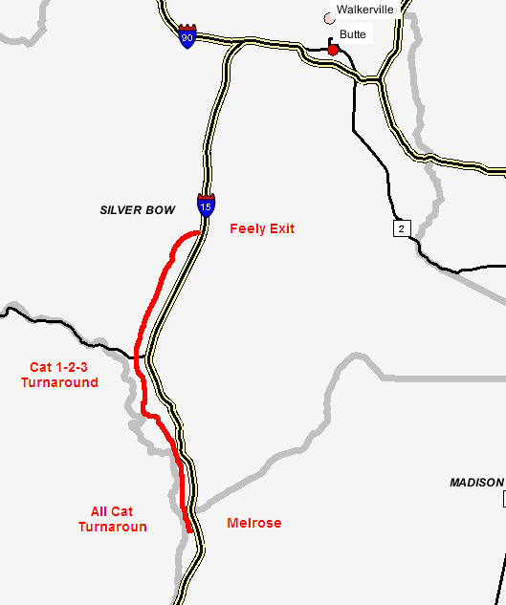

Directions to Feely (Registration)
From Butte, take I-90 west towards Missoula. After 5 miles, you will see the I-15 South (Idaho Falls) exit, take it. Travel south for 9 miles to the Feely exit (Exit 111); take this exit and turn west (right). Registration will be near the beginning of the dirt road.

FOR INFORMATION CONTACT:

John Coulthard
(406) 723-7606
Email: sherrycoulthard@in-tch.com
Web site: http://highlandscycling.org

